How did higher percentages of frequent physical or mental distress affect the relationship between environmental/ socioeconomic factors and COVID19 cases?
Reymond Lee
University of Toronto
Course Number: ECO225

Introduction
COVID-19 has had had a major impact in the world and its functioning. I wish to further explore the relationship between factors and COVID-19
Many studies have studied the link between weather and COVID19 cases. The consensus is usually that warmer weather leads to more cases, but the issue is that socioeconomic status could be different in warmer areas and that could be a confounder. For example, Sarkodie et al. (2021) suggests that while air pollution, high temperature, and high humidity can spur COVID-19, underlying health conditions and socioeconomic factors like income can confound this relationship. A study by Upadhyaya et al. (2022) confirms this fact by stating that socioeconomic factors obesity and income surprisingly has a negative effect on COVID-19 death rate. Additionally, Shen et al. (2020) find a significant effect of limiting socioeconomic activities on COVID-19 cases. Roy et al. (2020) corroborates this fact by finding that testing numbers, airport traffic, and age are significant factors in number of cases. So it is interpreted by them that high airport and road traffic plus population density leads to more cases.
Various methods have been used to explore this relationship. For example, Zhang et al. (2022) suggests using Pearson coefficients and Random Forest ML models, and Ahmed et al. (2021) suggests a negative binomial regression model.
My research question is “In 2020, how did higher percentages of frequent physical or mental distress moderate the relationship between environmental/socioeconomic factors and COVID19 cases across US counties, specifically California?”

In my research, I want to affirm that relationship plus explore an additional aspect of consideration known as physical and mental stress. I want to see how this factor interacts with what we already know. I plan to use linear regression and a random forest model, and supplementary web-scraping to explore this relationship.
Some studies like Ganslmeier et al. (2021) suggest a negative correlation between temperature, humidity, windspeed to COVID19 cases and I wish to explore that correlation with my temperature, dewpoint, and wind speed variables. Also, since Han et al. (2020) mention that the interaction of different types of pollution has a strong impact on cases, I included the PM2.5 variable to explore that effect. The physical and mental distress variables are there to add an additional vector for exploration. I wonder how those variables can interact with the already explored effects of other variables on COVID19 cases. Then I included some socioeconomic variables to cover their potential effect on COVID19 cases. For example, Benita et al. (2022) concludes that income inequality is positively correlated with transmission of the virus. I included education variables, measures of personal income, GDP, unemployment rate as socioeconomic variables. I think it is valuable to explore this since much research have stated there are limitations reducing the accuracy of their research.
Data
My dataset comes from a combination of data sources. The socioeconomic factors data comes from the US CDC metrics of "social vulnerability" and natural and man-made disasters. The weather data comes from the NOAA Global Surface Summary of the day, which links each county to a nearby weather station. Also, my dataset uses the County Health Rankings Data a dataset that contains many measures of community health. The data is county-level for all the United States.

Summary Statistics and Visualizations
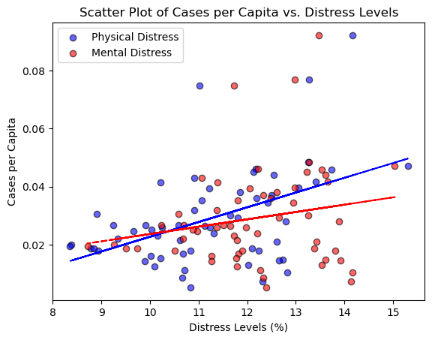
This graph tackles the initial problem and attempts to show whether physical or mental distress is more correlated with cases. We can see that physical distress is more correlated with cases than mental distress.
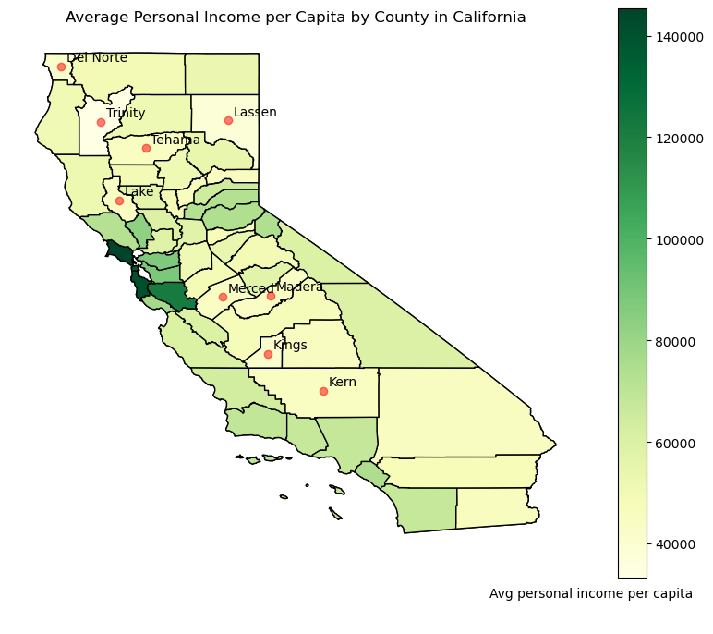
In this map, I have highlighted one of the important predictors: average personal income per capita in California. These locations with low average personal income per capita potentially respond worse to Covid-19. We see that countries with low personal income are primarily located in the central valley, the southeast, and the north. This is a similar pattern to the following map regarding cases per capita in California, so it is worth paying attention to predictors that vary in these rural areas when doing the research.

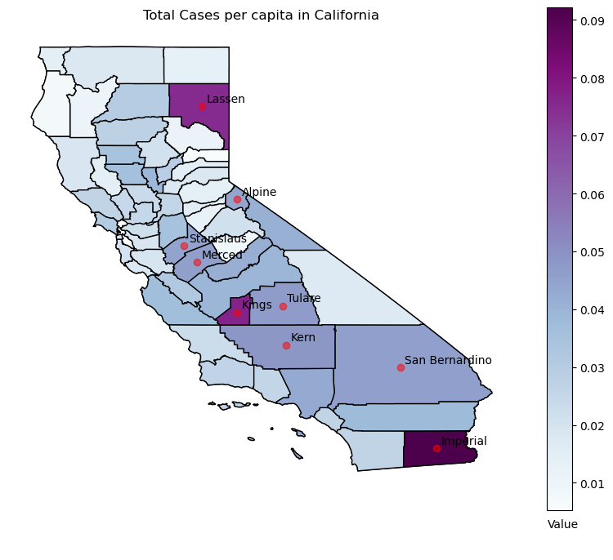
This is a map highlighting the main response variable cases per capita. I highlight the areas with the most cases per capita. We will look for correlation between the x variables and cases. Here we learn that areas with are primarily in the south, central valley, and north areas of California. This gives us potential insight that economic factors in rural areas might be correlated with cases.
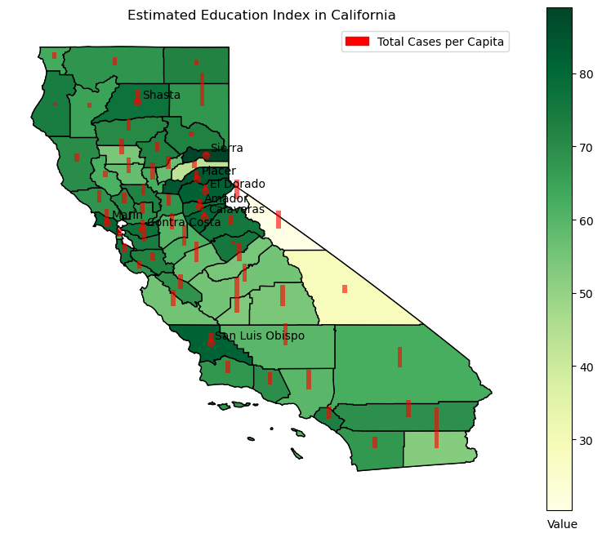
This is a map of my custom index of education where I take the high school graduation rate minus the percent of people without a high school diploma. I highlight the areas with the most education. We will look for correlation between this and cases. We learn that the central valley and the southeast have the most education. This again matches the pattern of the cases per capita map. Suggesting that areas with high education are correlated with cases.
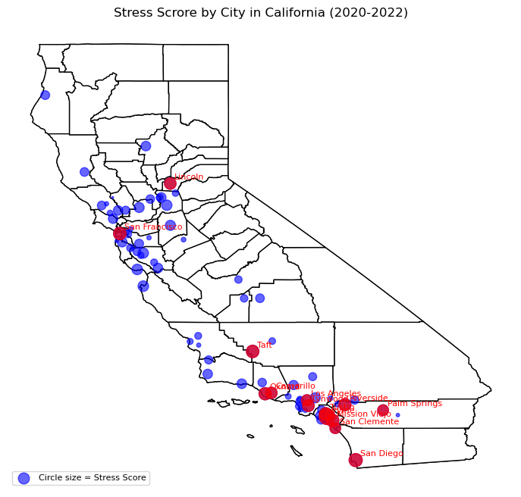
Here is the result of my web-scraping, I show the stress scores for the pandemic in a map. Specific properties of the region like income, education, and weather can confound the relationship between stress and COVID19 cases. So, highlighting the areas with high stress is insightful for future analysis. This data is useful in future city-level analysis regarding my research question.

Results
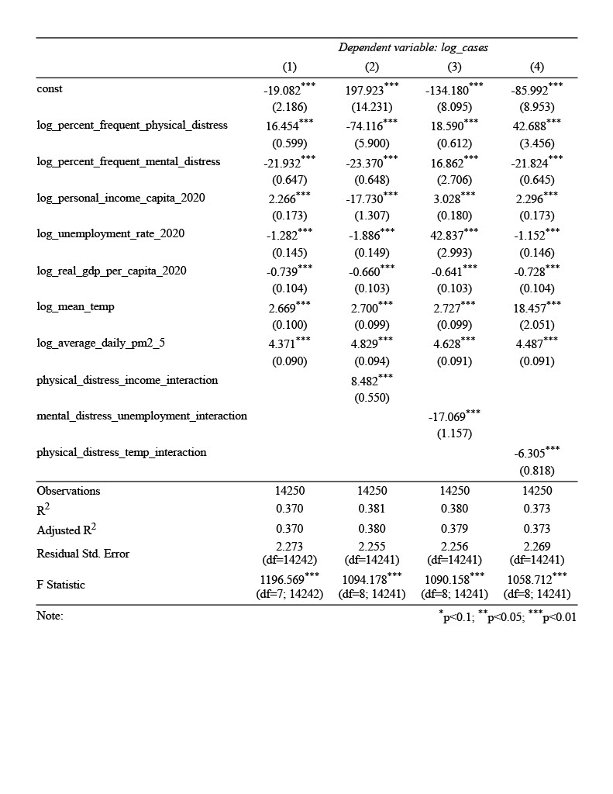
Most of my variables have a statistically significant coefficient at the 1% significance level which suggests the model is accurate. Also, the F statistic is high which suggests that the models as a whole are significant.
A log transformation was applied to correct the skewed data and ensure regression would be appropriate for the data.
The interpretation of the log-linear coefficients is that for every 1% increase in the coefficient, the number of cases increases or decreases by the value of the coefficient as a percent. For example, for every 1% increase in physical distress in model 1, the percent increase in cases is 16.54%
In terms of the interaction coefficients, the positive coefficient for the interaction between physical distress and income suggests that as physical distress increases the impact of income on cases increases. However, in terms of the interaction betweeen mental distress and unemployment, the negative coefficient suggests that as mental distress increases the effect of unemployment on cases decreases. The other two interaction terms have a similar negative coefficient leading to a similar interpretation.
For my research question, this suggests that physical distress increasingly affects the relationship between socioeconomic cases plus weather and cases and vice versa for mental distress.
This regression is my preferred specification for its insight into the moderation effect that my research question is asking.
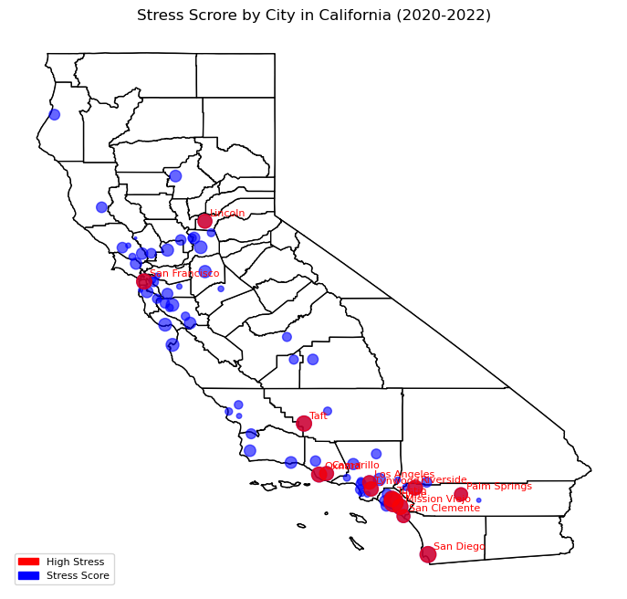
Here is a map summarizing the results of my web scraping, I show the stress scores for the pandemic in a map. Specific properties of the region like income, education, and weather can confound the relationship between stress and COVID19 cases. So, highlighting the areas with high stress is insightful for future analysis.
In regards to the OLS model versus the Machine Learning Model, the standard error for the regression appears to be lower than the mean squared error for the machine learning models.
However, machine learning are better at prediction and gives me some easy to interpret connections between the splitting variables and the response variable that allow me to draw new conclusions about prediction. For example, like how the value of one variable affects which other variable is better at predicting the outcome variable (cases)
However, OLS models are better for interpreting the relationship between the x variables and y variable. I was able to see whether the impact of x on y was positive or negative. Machine learning models are strictly only give information regarding prediction.

Conclusion
In this project, I hoped to add to existing research about weather, socioeconomic conditions, and COVID-19. To contribute to additional understanding about COVID-19, I run a regression to attempt to find out how physical and mental distress moderates the relationship between socioeconomic/weather variables and COVID-19 cases. I use a log linear regression model involving interaction terms to attempt to discover this effect. The result showed that physical distress primarily had a positive moderating effect, while mental distress had the opposite. In addition, I web scrape Reddit for additional data to enhance my analysis, and use decision trees and random forest models to predict cases.
In the future, I plan to consider implementing additional controls and doing for in-depth data sources for web-scraping and cleaning the data better so it can be used in regression analysis. Also, more models other than Random Forest ML models I plan to use in the future to enhance my analysis. Future controls could include dummies regarding overcrowding/ social distancing measures like how Shen et al. (2020) explored it. Satellite data would be an intriguing way to integrate this data in future research. Also, in the future I could add demographic data as controls to the analysis as well.

References
Benita, F., Rebollar-Ruelas, L., & Gaytán-Alfaro, E. D. (2022). What have we learned about socioeconomic inequalities in the spread of COVID-19? A systematic review. Sustainable cities and society, 86, 104158. https://doi.org/10.1016/j.scs.2022.104158
Han, Y., Zhao, W., & Pereira, P. (2022). Global COVID-19 pandemic trends and their relationship with meteorological variables, air pollutants and socioeconomic aspects. Environmental research, 204(Pt C), 112249. https://doi.org/10.1016/j.envres.2021.112249
Sarkodie, S. A., & Owusu, P. A. (2021). Global effect of city-to-city air pollution, health conditions, climatic & socio-economic factors on COVID-19 pandemic. The Science of the total environment, 778, 146394. https://doi.org/10.1016/j.scitotenv.2021.146394
Ahmed, J., Jaman, M. H., Saha, G., & Ghosh, P. (2021). Effect of environmental and socio-economic factors on the spreading of COVID-19 at 70 cities/provinces. Heliyon, 7(5), e06979. https://doi.org/10.1016/j.heliyon.2021.e06979
Zhang, X., Maggioni, V., Houser, P., Xue, Y., & Mei, Y. (2022). The impact of weather condition and social activity on COVID-19 transmission in the United States. Journal of environmental management, 302(Pt B), 114085. https://doi.org/10.1016/j.jenvman.2021.114085
Ganslmeier, M., Furceri, D., & Ostry, J. D. (2021). The impact of weather on COVID-19 pandemic. Scientific reports, 11(1), 22027. https://doi.org/10.1038/s41598-021-01189-3
Shen, X., Cai, C., & Li, H. (2020). Quantifying socioeconomic activities and weather effects on the global spread of COVID-19 epidemic. https://doi.org/10.48550/arxiv.2005.10223
Roy, S., & Ghosh, P. (2020). Factors affecting COVID-19 infected and death rates inform lockdown-related policymaking. PloS One, 15(10), e0241165–e0241165. https://doi.org/10.1371/journal.pone.0241165
Upadhyaya, A., Koirala, S., Ressler, R., & Upadhyaya, K. (2022). Factors affecting COVID-19 mortality: an exploratory study. JOURNAL OF HEALTH RESEARCH, 36(1), 166–175. https://doi.org/10.1108/JHR-09-2020-0448

Footnotes
¹For APA reports, add footnotes manually on their own page following references. Do not use the Insert Footnotes method on the References tab as they will not be formatted correctly. For APA formatting requirements, it’s easier to type your own footnote references and notes. To format a footnote reference, select the number and then, on the Home tab, in the Styles gallery, click Footnote Reference. The body of a footnote, such as this example, uses the Normal text style. If you delete this sample footnote, don’t forget to delete its in-text reference at the end of the sample Heading 2 paragraph on the first page of body content in this template.

Tables
Table 1
Table Title
Column Head | Column Head | Column Head | Column Head | Column Head
Row Head | 123 | 123 | 123 | 123
Row Head | 456 | 456 | 456 | 456
Row Head | 789 | 789 | 789 | 789
Row Head | 123 | 123 | 123 | 123
Row Head | 456 | 456 | 456 | 456
Row Head | 789 | 789 | 789 | 789

Note: Place all tables for your paper in a tables section, following references and footnotes. Start a new page for each table, include a table number and table title for each, as shown. All explanatory text appears in a table note that follows the table, like this one. Use the Table/Figure style, available on the Home tab, in the Styles gallery, to get the spacing between table and note. Tables in APA format can use single or 1.5 line spacing. Include a heading for every row and column, even if the content seems obvious. A default table style has been set up for this template that fits APA guidelines. To insert a table, on the Insert tab, click Table.

Figures Title
Figure 1.
Include all figures in their own section, following references, footnotes, and tables. Include a numbered caption for each figure. Use the Table/Figure style for easy spacing between figure and caption.

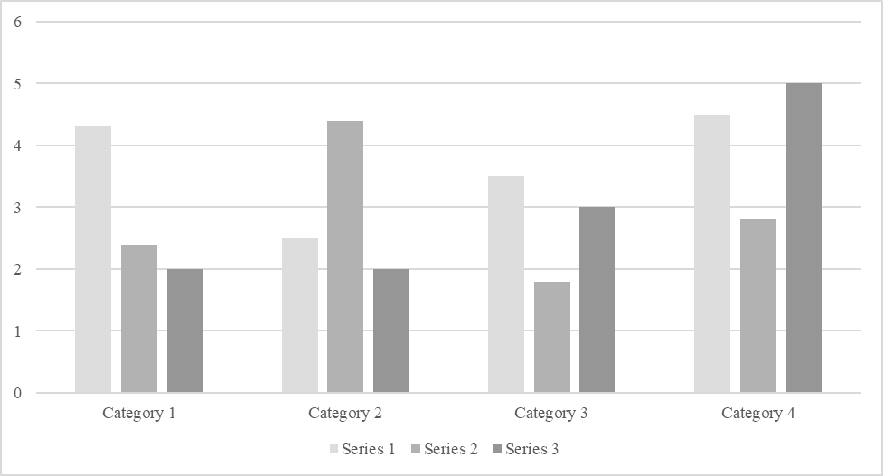

For additional information on APA Style formatting, please consult the APA Style Manual, 7th Edition.

